**GETTING URL PARAM FROM REQUEST DJANGO**

REF:

<https://stackoverflow.com/questions/29660423/how-can-i-access-url-parameters-from-within-a-basepermission>

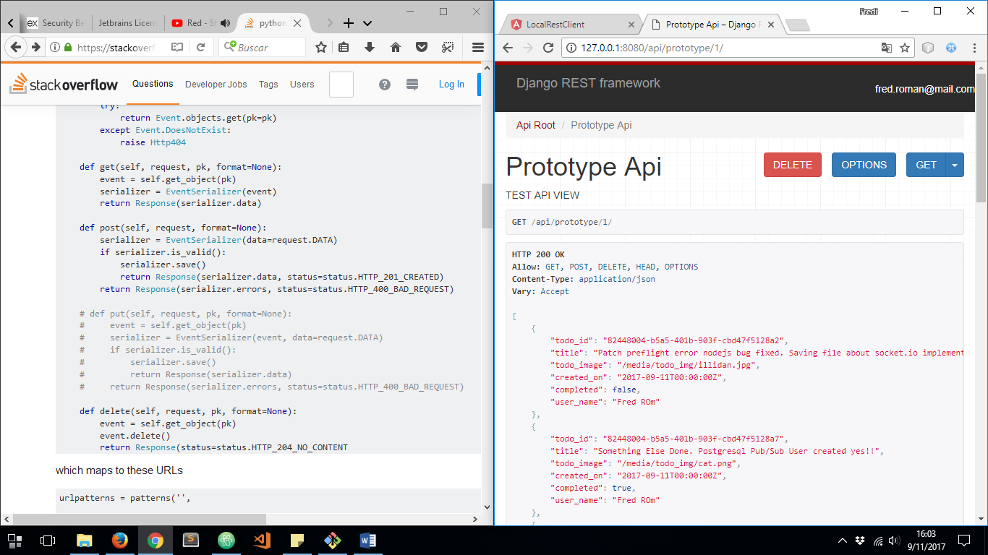

TO GET URL PARAM VALUE WE HAVE TO DO NEXT:

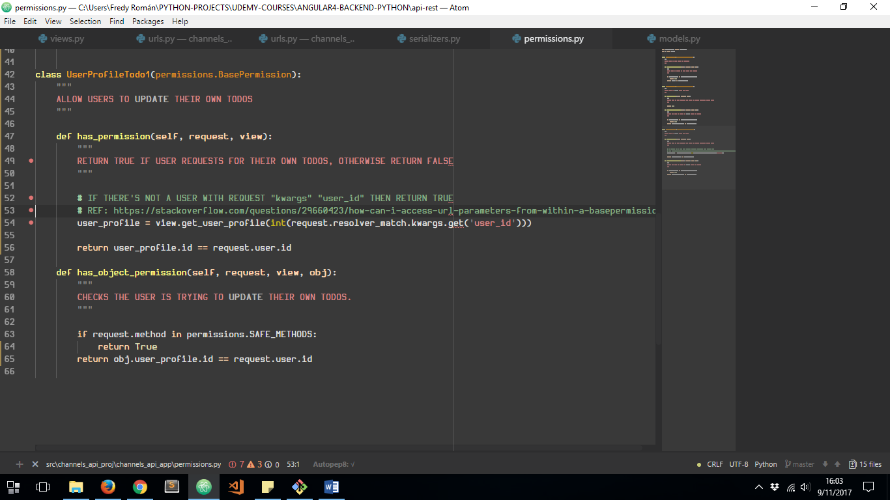

***user_id*** IS THE URL PARAM SPECIFIED ON ***urls.py*** FILE:

